OSSP (Operating Systems and Systems Programming) – 25CS2104E
OSSP LAB – SKILL-2

Aim
To develop and test an interactive command-line loop that displays a prompt, reads user input, handles exit conditions, captures keyboard input including backspace and Enter keys, manages the input buffer, and supports multi-character commands.

Algorithm
- Start the program.
- Display the command prompt.
- Read characters entered by the user.
- Store the characters in an input buffer.
- If a normal character is entered, add it to the buffer.
- If Backspace is pressed, remove the last character from the buffer.
- If Enter is pressed, terminate the current input and process the command.
- Check whether the entered command is an exit command.
- If it is an exit command, terminate the loop and end the program.
- Otherwise, process and display the entered command.
- Return to the main loop and display the prompt again.
- Test the loop with single-character and multi-character commands.
- Stop the program.

Step 1

Step 2
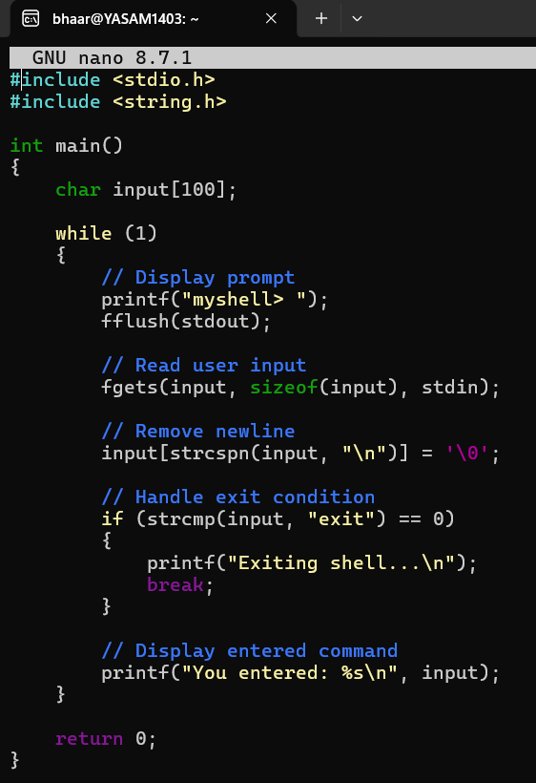

Step 3
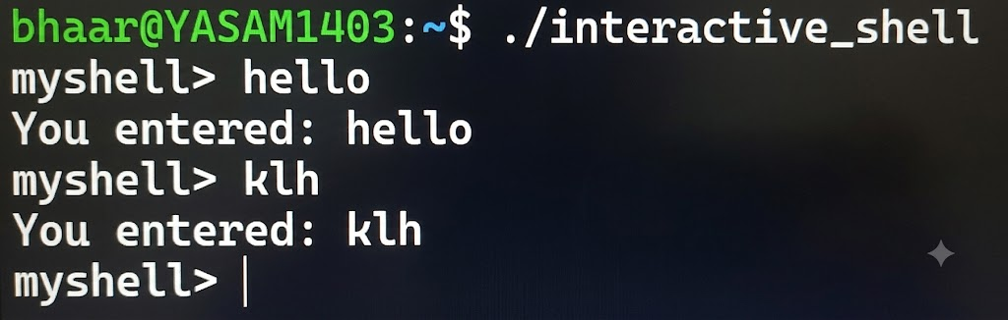

Step 4

Step 5

Step 6
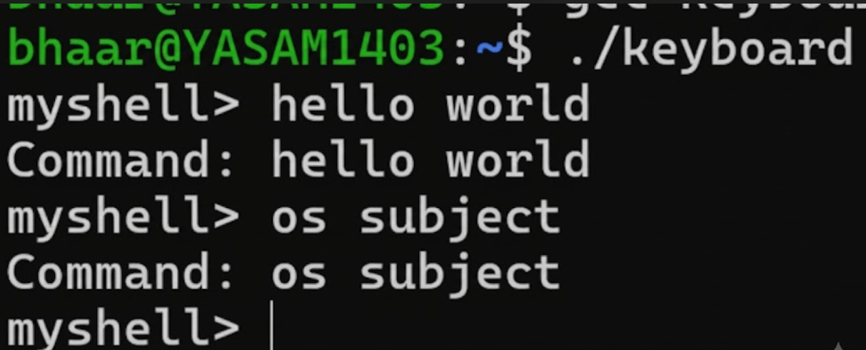

Conclusion
The interactive command-line loop was successfully designed and tested. It correctly displays the prompt, accepts keyboard input, handles Backspace and Enter, manages the input buffer, supports multi-character commands, and terminates when an exit condition is received.

